Solving farmers queries using chatbot
Dr.S.Srinivas Rao Kadimisetti Suman Madhav Reddy
Associate Professor Student
Department Of CSE Department Of CSE
Koneru Lakshmaiah Education Foundation Koneru Lakshmaiah Education Foundation
Vaddeshwaram, India Vaddeshwaram, India
srinu1479cse@kluniversity.in 170031572@kluniversity.in

T.Chaitanya Sreenivas G.Harika
Student Student
Department Of CSE Department Of CSE
Koneru Lakshmaiah Education Foundation Koneru Lakshmaiah Education Foundation
Vaddeshwaram, India Vaddeshwaram, India
170031255@kluniversity.in 170030381@kluniversity.in

G.Sai Sowmya
Student
Department Of CSE
Koneru Lakshmaiah Education Foundation
Vaddeshwaram, India
170030408@kluniversity.in

Abstract. Farmers on Internet There are around 14 crore farmers in India. The majority of us accept farmers don't utilize internet. So what's the point of messing with this? In any case, the circumstance may be changing quietly directly in front of us (and may as of now have changed!). According to the most recent report by The Internet and Mobile Association of India (IAMAI), there are as of now around 11 crore individuals in rural India who are getting to internet by means of their mobiles (not just mobile, but mobile internet!). Nonetheless, the truth implies more than this. Paper is an agriculture-based chatbot which answers addresses identified with farming practices. It is an intuitive chatbot which is prepared utilizing agriculture information of India. It utilizes its own hand crafted dataset. It can acknowledge both text and speech input. It is planned to be also incorporate Hindi, English and kannada as an alternate language. It utilizes a basic Neural Network to distinguish intent of the user question.After the intent is recognized, the elements are extricated utilizing a training dataset which we uses to identify custom entities characterized in the dataset. Based on the intent, we checks if all the essential entities are given by the user, if not, at that point we prompts the user for additional necessary information to respond to the inquiry. The appropriate response is then gotten from the dataset utilizing the information provided by the user and is displayed to the user.
Keywords: Chatbot, Neural Network, Language.
- Introduction
We would like to built a chatbot for farmers to resolve different queries related to agriculture with in a short time and to assist farmers in different situations to get better agriculture production and give plenty of information about agriculture thorough this chatbot.

There are many problems faced by farmers due to lack of information available to the so we will assist then through chatbot in following fields.

1.1 Diseases:
After the plantation due to lot of bacteria and insects crops may damage then if farmer interacts with chatbot it will suggest certain things to get out of the diseases.

1.2 Details of agricultural officers:
Most of the farmers might not be knowing about their agricultural officer so we will provide complete details regarding officers in agriculture with contact information.

1.3 Industries nearby and schemes:
Some of farmers don’t know about the industries near to them and they plan to cultivate other crops which product has to be taken to factory which is far to them so we will assist him in way that whatever factory is near to him so that they can produce product required to that factory and can easily take that to factory after harvest. Mainly farmers don’t have knowledge about the schemes offered by government and other private organisations if they know about certain schemes they will be benifitted so we will provide complete information of schemes available to them.

1.4 Soil fertility:
Now a days everyone is so planned unlike in olden days so farmers are asking for the crops suitable for certain soil and information about soil testing and the complete details of the crop suitable for that soil so we are providing them the information.

1.5 Crop rotation:
Crop rotation is the best practice to increase production for different agriculture products because when we grow one crop it takes all the minerals required so soil loses those minerals. At that point after harvesting we need to grow another crop which requires minerals other than previous crop mineral and gives the minerals that are taken by the previous crop to the soil. As this information is crutial we are making this easily available to the farmer.

1.6 Languages:
As all we know that many of the Indians don’t have good knowledge in English so we will try to make this chatbot available in minimum of three languages which are Telugu, Hindi, English we can give info both in text and voice with these languages.

1.7 Crops:
Whenever the farmers try to know the complete knowledge about certain crops they are not able to get that in a single platform so we are making that possible by giving plenty of information whenever farmers asked for details of certain crops.

- LITERATURE SURVEY
A chatbot is a software application which is used for conversation, it became very important as there is no need of human interference to work and the chatbot itself can give answers to the questions asked by the persons by using its knowledge and predefined datasets.
This chatbot is available in every field like education, industries, telecommunication …..etc but it is very strange to the agriculture field, even though some of the chatbots are available for in agriculture field for the farmers but none of them are capable of giving all the information. Some are not having proper facilities like available in different languages and giving information about agriculture officers and industries nearby.
  - Chatbot for farmers:
It is developed such that farmers can text and give voice command to the chatbot and in return they will get the answers for their queries. The chatbot is working continuously 24/7 and this is the main change we can see as in olden days the call centers will be closing after 5. Chatbot will give accurate information but manual interaction may lead to wrong outputs to farmers. By taking details of agricultural officers and factories nearby we can not be getting updated information but as chatbot is taking information from official agriculture websites it will be helpful for farmers in a better way.
In this field, several research studies have been undertaken. They are distinguished by the algorithm approach on the basis of Selection or the deployment process. The literature that follows For our project, reference was given to: The question of Indian farmers with regard to their
The selection of the best crop is resolved on the basis of its soil quality. Using different recommendations, the recommendation framework is established Algorithms for classification. The system operates in a system that Uh GUI.
The simulation and growth of Precision Farming is being debated. The primary objective of this device It is to explicitly contact farmers through emails and emails. About different advisory schemes. The model is being developed and To aid farmers, even with very low technical requirements, Awareness or rather small-scale agriculture.
A virtual assistant that helps users to explain their questions in a user-friendly manner. Chatbot for farmers. The input from the consumer is received. If the question is based on a forecast, the potential forecasts for the requested agricultural products are shown in graphic format and presented to the consumer.

- Existing system
The chatbots available now in the agriculture field for farmers are only taking queries in single language.
Details of agriculture officers and industries nearby a certain place are not clear and accurate in previous chatbots.
The user interface of chatbots are not attractive and farmers may confuse if they use such chat bots.
Till now the available chatbots in agriculture field are not accurate enough to give information which is 100% useful for the farmers.
They are providing information related to crops but not resolving the queries of the farmers. Complete details of pesticides are not accurate.

- Proposed system
The solution suggested is to construct a Chabot to simulate a Human conversation to support workers with their needs And to have an experience that is more intimate. Progresses In artificial intelligence, methods for machine learning, Improved decision-making capacity, greater availability of The practicality of the domains and corpus has improved Integration of a Chabot into software. Users will be able to ask any queries in natural language that they are comfortable using such as, information about crops, agriculture officers details, industries nearby. The chat boat will identify and understand what the user is asking and generate an appropriate response based on the conversational context. Immediate response will be provided by the chatbot to give the information to the farmers and other users who are using this chatbot.

The flowchart of the system displays how the chatbot performance. Initially the chatbot welcomes the farmers and other users then ask for the queries. It gets the user defined language query does identify the entities. It will fetch the data from the database, if answers are there it will display the answers. This chatbot will display the answers in four different languages even we can ask this chatbot queries in those four different languages.

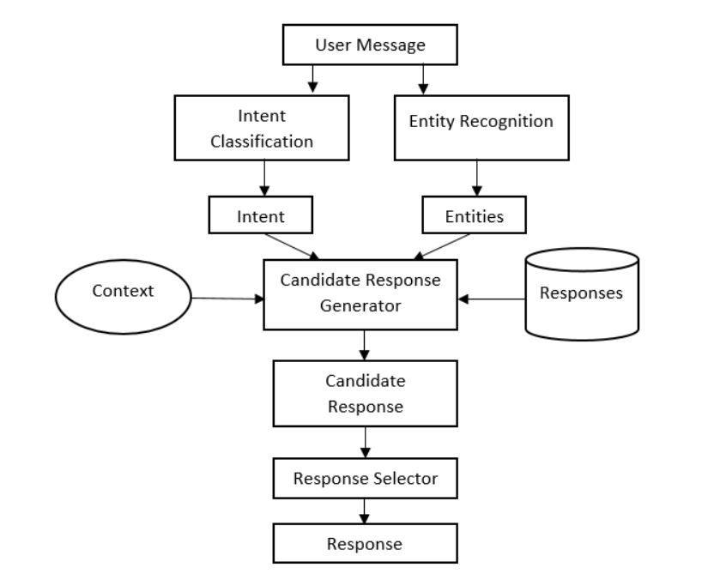

Fig.4.1 The above figure says the process of chatbot in which the user message is taken first and sent to intent classification and entity recognition then they are sent to candidate response generator finally we will get candidate response then response selector as in previous step there are many responses finally response is displayed.

4.1 Tkinter:
Tkinter is inbuilt python model for crating GUI (graphical user interface) there are other different models to create GUI but tkinter is the mostly used and best model. Tkinter need not be installed separatly it comes with the python.
There are other different ways to build GUI in Tkinter's built-in phython platform for crating GUI (graphical user interface), but tkinter is the most widely used and better model. It comes with the python and Tkinter does not need to be built separately.
Originally designed for the Tool Command Language, the Tkinter toolkit is based on Tkinter (Tcl). As Tk is very popular, it has been ported to a number of other scripting languages, including Perl (Perl/Tk), Ruby (Ruby/Tk), and Python (Tkinter). (Tkinter).It comes with the python and Tkinter does not need to be built separately.
Originally designed for the Tool Command Language, the Tkinter toolkit is based on Tkinter (Tcl). As Tk is very popular, it has been ported to a number of other scripting languages, including Perl (Perl/Tk), Ruby (Ruby/Tk), and Python (Tkinter). Portabilit, Portabilit

4.2 Cosine similarity:
In data mining similarity is measured by the distance along with dimensions which represent the features of the data object in dataset. If distance is less there will be high similarity, if the distance is large then there will be low similarity. There are mays ways to measure similarity 1 euclidean distance 2 jaccard similarity 3 manhattan distance 4 cosine similarity 5 minkowski distance. among the above similarity measures cosine similarity is user friendly and more accurate. We can find how the data objects are similar irrespective of their size. Similarity of the two sentences in python can be measured by cosine similarity. In this cosine similarity data objects are treated as vector. There is formula for finding the similariy of two vectors.

Cos(x, y) = x . y / ||x|| * ||y||
Where,
X.Y=product of two vectors ‘x’ and ‘y’.
||x|| and ||y||=length of the two vectors ‘x’ and ’y’.
||x|| * ||y|| = cross product of vectors ‘x’ and ’y’.

4.3 Tokenization:
In tokenization big quantity of text is divided into smaller parts called tokens.
Natural language processing is used For building applications like intelligent chatbot, language translation .etc. So it becomes important to understand the pattern of the words in the particular sentence So these tokens are used to find such patterns easily.

4.3.1 Word tokenization
In this photo organisation we divide sentences into words and further The output of words are converted to Data frame for better understanding in machine learning applications. Finally it can also be provided as further input For text cleaning steps like punctuation removal, numeric character removal etc.

4.3.2 Sentence tokenization
As we already have known about word tokenization but we have a question that why should we have sentence tokenization if we need to count the average words how we need to count ? So for doing such tasks we need both word and sentence tokenization.

4.4 Stop words:
Stop Words are words to be used in search queries that do not contain significant meaning. These terms are usually filtered out of search queries because they return large quantities of unnecessary data.Words that do not appear in a specificdatabase in the index because they are either trivial (i.e. posts, prepositions) or so abundant that the results are higher than the system can manage (as in the case of IUCAT where terms such as United States or Department are keyword search stop words). Stop words differ from system to system. Some systems will also completely disregard stop words, where the use of stop words in other systems will result in zero hits being retrieved.

4.5 Random algorithm:
A supervised learning algorithm that is used for both classification and regression is Random Forest. But it is, however, primarily used for problems with classification. As we know, a forest is made up of trees, and more trees make the forest stronger. Similarly, the random forest algorithm produces decision trees on data samples and then gets the prediction from each of them and selects the best solution by voting. It is an ensemble technique that is better than a single decision tree because by combining the result, it decreases the over-fitting.
Random Forest Algorithm Working
With the aid of the following steps, we should understand the work of the Random Forest algorithm.
1 Start by selecting random samples from a given dataset first.
2 Next, for each sample, this algorithm will create a decision tree. Then, from any decision tree, it will get the prediction result.
3 For any predicted outcome, voting will be carried out in this step.
4 Eventually pick the outcome of the most voted prediction as the final result of the prediction.

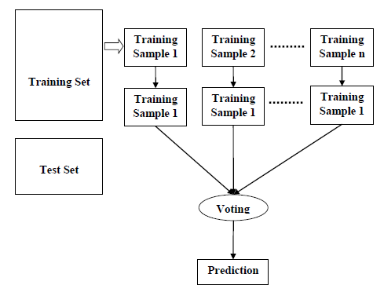

Fig.4.2 The above figure describes about the stages and working of random algorithm in which first the selection of samples from dataset is shown and these datasets further converted to decision tree from any decision tree we will get the prediction result.

4.6 Tfidfvectorizer:
At the starting level, the word count from text documents is very simple. Simple word count, however is not adequate for text processing due to the high occurrence of terms such as the", "an", "your", etc. in text documents. Their high word count is unrelated to the interpretation of the document. Tf-idf can be used effectively for filtering stop-words from a text document.
The other way to resolve this issue is word frequency. This approach is referred to as "Term Frequency-Inverse Document Frequency" by TF-IDF. TF-IDF is a numerical statistic that calculates in a document the value of the term.

Term Frequency: The time a word is displayed in a text document.
Inverse Document Frequency: A uncommon word or common word in a document is a measure of the word.

- Results
For the graphical user interface we have used tkinter in which a box for conversation opens and user can give a question or query by typing in search and to enter. Then the system takes the sentence and it will count the words using sentence tokenization. After the sentence tokenization word tokenization in which words are separated and The output of words are converted to Data frame for better understanding in machine learning applications. Finally it can also be provided as further input For text cleaning steps like punctuation removal, numeric character removal etc. At this point stop words are removed from the text by python stop words application and using cosine similarity it will compare the similarity between sentences for giving answer in a better way finally the answer is displayed in the box in four different languages even though we have given the question in one of the four languages thus by this way user will get the accurate answers for their questions. If the user asks about the details of the officers and factories it will display only the required information but if the user asks the details complety about certain crop it will show all the details including the crop intakes and outcomes.

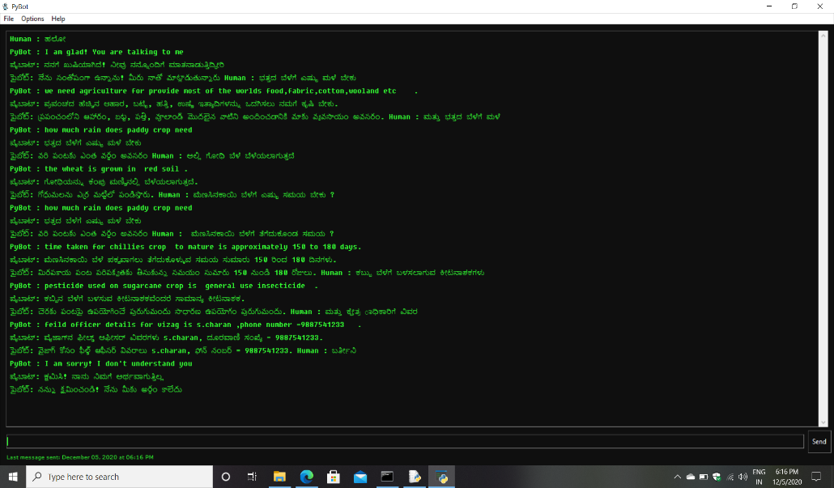

Fig.5.1 The fig. 1 is screenshot of outputs when the questions are asked and send to the application.

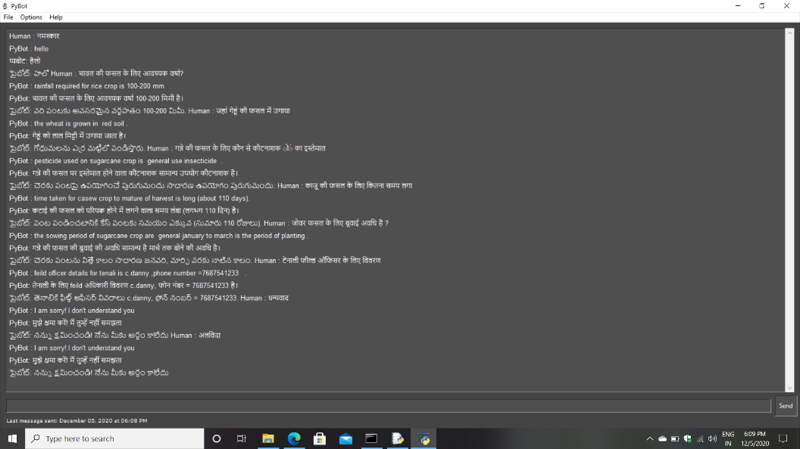
Fig.5.2 The above figure shows the outputs in Hindi, Telugu, English.

- Summary
Chatbot for farmers will solve many problems of farmers by giving accurate information about agriculture and about complete information of some crops. will help farmers by giving plenty of information about agriculture officers factories near to them and mainly it will give good information about which soil is suitable for the crop along with weather condition in which crop should be grown. these details and other queries which comes into the mind of farmers will be solved and helpful for the farmers in a way that they can get information and produce crops With increase in quality and quantity. This chatbot for farmers will also be useful for young generation who aspire to learn farming or known about the farming as the user interface is pretty interactive. farmers can easily understand and use this application. This is in many ways it is useful for the farmers so it is a way to the farmers to get good information.

- Conclusion
Form the start of this project we have interacted with many farmers and agriculture workers and listen to them and we are shocked about the problems faced by small things like not knowing what to do for certain diseases or which crop is to be cultivated at that particular time in certain soil. We tried a lot to find solution to these problems by technology finally after long search we came to conclusion that we have to built a chatbot for farmers which can give solutions to the each question asked by the farmers. In this project we made chatbot by which farmers will get information related to agriculture and they can also search for complete information of different crops through voice command and this chatbot will also understand and respond in four languages if we want, we can make more, this feature will be very useful for farmers as they might only their mother language. Farmers can also see contact and location of agricultural officers and factories near to them. As by this farmer can get lots of information to cultivate better crop and to grow that crop and to harvest.
- Future scope
The chatbot is further developed by making it recognize the speaker for security purpose. It can be made to take pictures of certain information and questions like soil tested results photos and has to give appropriate answer. Mainly we can expand this chatbot by giving information about more crops and developing in a way that it is not limited to certain state and has to be used by the whole country. The details of prices and prediction of prices of agricultural products can also be implemented. This project can be made such that farmers can fix meetings with the agriculture officers and that of other agriculture related technicians for different purposes this may useful for farmers by saving time and money.
- References
- Divya Sawant , Anchal Jaiswal , Jyoti Singh, Payal Shah , AgriBot - An intelligent interactive interface to assist farmers in agricultural activities , 2019 IEEE Bombay Section Signature Conference (IBSSC)
- Sharvari Gaikwad,Rohan Asodekar,Sunny Gadia,Vahida Z. Attar , AGRI-QAS Question-Answering System for Agriculture Domain , 2015 International Conference on Advances in Computing, Communications and Informatics (ICACCI)
- Manmita Devi ,Mohit Dua , ADANS: An Agriculture Domain Question Answering System using Ontologies , International Conference on Computing, Communication and Automation (ICCCA2017)
- Prashant Y. Niranjan,Vijay S. Rajpurohit ,Rasika Malgi , A Survey on Chat-Bot system for Agriculture Domain , 2019 1st International Conference on Advances in Information Technology
- Prof Shabana Tadvi ,Sultanat Rangari,Ammar Rohe , HR Based Interactive Chat bot (PowerBot) ,IEEE-2020
- J. Vijayalakshmi, K. PandiMeena, Agriculture TalkBot Using AI, International Journal of Recent Technology and Engineering (IJRTE) ISSN: 2277 – 3878, Volume-8, Issue-2S5, July 2019
- MOHIT JAIN , PRATYUSH KUMAR, ISHITA BHANSALI Q. VERA LIAO, KHAI TRUONG, SHWETAK PATEL, FarmChat: A Conversational Agent to Answer Farmer Queries.
- Intelligent Interactive Robot System for Agricultural Knowledge Popularity and Achievements Display, 2019 IEEE 4th Advanced Information Technology, Electronic and Automation Control Conference (IAEAC 2019)
- Muhammad Faisal , Rahman, Fadly Shabir , Ida , Design and Implementation of Plantation Commodities Price Information Broadcaster via Autoreply Short Message Service on Smartphone.
- https://codeburst.io/2-how-assistant-work-introduction-to-dialogflow
- https://dialogflow.com/docs/tutorial-build-an-agent
- https://openweathermap.org/
- https://www.analyticsvidhya.com/blog/2016/04/complete-tutorial-treebased-modeling-scratch-in-python/
- https://acadgild.com/blog/decision-tree-python-code
- https://www.analyticsvidhya.com/blog/2015/06/tuning-random-forestmodel/
- https://machinelearningmastery.com/k-nearest-neighbors-for-machinelearning/
- https://data.gov.in/catalog/district-wise-season-wise-crop-productionstatistics
- http://maharain.gov.in/
- https://www.wordstream.com/blog/ws/2017/10/04/ch atbots
- https://www.inc.com/larry-kim/10-examples-of-howbrands-are-using- chatbots-tode.html
- https://github.com/PoorvaRane/EmotionDetector/blob/master/Emotion_Detector.ipynb
- https://blog.statsbot.co/chatbots-machine-learninge83698b1a91e
- https://link.springer.com/chapter/10.1007/978-3-319- 19156-0_14
- Khan, F.M., Fisher, T.A., Shuler, L., Wu, T., Pottenger, W.M. Mining Chat-room Conversations for Social and Semantic Interactions. Can be found on the WWW:
- http://www.cse.lehigh.edu/techreports/2002/LU-CSE-02- 011.pdf. 2002
- Philipp Michel. Support vector machines in automated emotion classification. Churchill College, June 2003.
- Building Chatbot with Emotions- Honghao WEI, Yiwei Zhao, Junjie Ke

